A

Minor Project

On

**INDOOR SCENE CLASSIFICATION USING VGG-19 AND CNN CLASSIFIER**

(Submitted in partial fulfilment of the requirements for the award of Degree)

BACHELOR OF TECHNOLOGY

in

COMPUTER SCIENCE AND ENGINEERING

By

B.Varsha

(19E41A0577)

K.Mohan Teja

(19E41A0581)

Darshan Joshi

(19E41A0586)

T.Varun Raj

(19E41A0599)

Under the Guidance of

Dr. S Venkata Achuta Rao

(Principal)



**DEPARTMENT OF COMPUTER SCIENCE AND ENGINEERING**

**SREE DATTHA INSTITUTE OF ENGINEERING AND SCIENCE**

(Accredited by NAAC, Affiliated to JNTUH, Approved by AICTE, New Delhi)

Recognized Under Section 2(f) of the UGCAct.1956,

Sheriguda (V), Ibrahimpatnam (M), Ranga Reddy – 501510.

**2019-2023**

**DEPARTMENT OF COMPUTER SCIENCE AND ENGINEERING**



**CERTIFICATE**

This is to certify that the project entitled “**INDOOR SCENE CLASSIFICATION USING VGG-19 AND CNN CLASSIFIER** ” is being submitted by **B.VARSHA (19E41A0577), K.MOHAN TEJA (17E41A0581), DARSHAN JOSHI (19E41A0581), T.VARUN RAJ(19E41A0599)** in partial fulfilment of the requirements for the award of the degree of B.Tech in Computer Science and Engineering to the Jawaharlal Nehru Technological University Hyderabad, is a record of bonafide work carried out by him/her under our guidance and supervision during the year 2022-23.

The results embodied in this thesis have not been submitted to any other University or Institute for the award of any degree or diploma.

**P.Divya Sree Dr.** **Achuta Rao**

**Internal Guide Principal**

**Dr. M. Varaprasad Rao External Examiner**

**HoD**

**Submitted for viva voice Examination held on _____________________**

**ACKNOWLEDGEMENT**

Apart from our efforts, the success of any project depends largely on the encouragement and guidelines of many others. We take this opportunity to express our gratitude to the people who have been instrumental in the successful completion of this project.

We take this opportunity to express my profound gratitude and deep regard for my guide **Mrs. P. Divya Sree,** Assistant Professor for his exemplary guidance, monitoring and constant encouragement throughout the project work. The blessing, help and guidance given by him shall carry us a long way in the journey of life on which we are about to embark.

We are also thankful to **Dr. M. Varaprasad Rao,** Head, Department of Computer Science and Engineering for providing encouragement and support for completing this project successfully.

We are obliged to **Dr.Achuta Rao,** Principal for being cooperative throughout this project. We would like to express our sincere gratitude to **Dr. GNV Vibhav Reddy**, Vice-Chairman and **Sri.** **G. Panduranga Reddy,** Chairman for providing excellent infrastructure and a nice atmosphere throughout this project.

The guidance and support were received from all the members of **Sree Dattha Institute of Engineering and Science** who contributed to the completion of the project. We are grateful for their constant support and help.

Finally, we would like to take this opportunity to thank our family for their constant encouragement, without which this assignment would not be completed. We sincerely acknowledge and thank all those who gave support directly and indirectly in the completion of this project.

**TABLE OF CONTENTS**

|  |  |  |  |  |  |  |  |
| --- | --- | --- | --- | --- | --- | --- | --- |
| **ABSTRACT** | | |  |  | | | I |
| **LIST OF FIGURES** | | | |  | | | II |
| **LIST OF SCREENSHOTS** | | | | | | | III |
| **1.** | **INTRODUCTION** | | | | | | 1 |
|  | 1.1 | | PROJECT SCOPE | | | | 1 |
|  | 1.2 | | PROJECT PURPOSE | | | | 1 |
|  | 1.3 | | PROJECT FEATURES | | | | 1 |
| **2.** | **SYSTEM ANALYSIS** | | | | | | 2 |
|  | 2.1 | | PROBLEM DEFINITION | | | | 2 |
|  | 2.2 | | EXISTING SYSTEM | | | | 2 |
|  |  | | 2.2.1 | LIMITATIONS OF THE EXISTING SYSTEM | | | 3 |
|  | 2.3 | | PROPOSED SYSTEM | | | | 3 |
|  |  | | 2.3.1 | ADVANTAGES OF PROPOSED SYSTEM | | | 4 |
|  | 2.4 | | FEASIBILITY STUDY | | | | 4 |
|  |  | | 2.4.1 | ECONOMIC FESIBILITY | | | 4 |
|  |  | | 2.4.2 | TECHNICAL FEASIBILITY | | | 4 |
|  |  | | 2.4.3 | BEHAVIORAL FEASIBILITY | | | 5 |
|  | 2.5 | | HARDWARE & SOFTWARE REQUIREMENTS | | | | 5 |
|  |  | | 2.5.1 | HARDWARE REQUIREMENTS | | | 5 |
|  |  | | 2.5.2 | SOFTWARE REQUIREMENTS | | | 5 |
| **3.** | **ARCHITECTURE** | | | | | | 6 |
|  | 3.1 | | PROJECT ARCHITECTURE | | | | 6 |
|  | 3.2 | | DESCRIPTION | | | | 6 |
|  | 3.3 | | USECASE DIAGRAM | | | | 7 |
|  | 3.4 | | CLASS DIAGRAM | | | | 7 |
|  | 3.5 | | SEQUENCE DIAGRAM | | | | 8 |
|  | 3.6 | | ACTIVITY DIAGRAM | | | | 9 |
| **4.** | **IMPLEMENTATION** | | | | | | 10 |
|  | 4.1 | | SAMPLE CODE | | | | 10 |
| **5.** | **TESTING** | | |  | | | 12 |
|  | | 5.1 | INTRODUCTION TO TESTING | | | | 12 | |
|  | | 5.2 | TYPES OF TESTING | | | | 12 | |
|  | |  | 5.2.1 | | | UNIT TESTING | 12 | |
|  | |  | 5.2.2 | | | INTEGRATION TESTING | 12 | |
|  | |  | 5.2.3 | | | FUNCTIONAL TESTING | 12 | |
|  | | 5.3 | TEST CASES | | | | 13 | |
|  | |  | 5.3.1 | | | UPLOADING IMAGES | 13 | |
|  | |  | 5.3.2 | | | CLASSIFICATION | 13 | |
| **6.** | **SCREENSHOTS** | | | | | | 14 |
| **7.** | | **CONCLUSION & FUTURE SCOPE** | | | | | 16 | |
|  | | 7.1 | PROJECT CONCLUSION | | | | 16 | |
|  | | 7.2 | FUTURE SCOPE | | | | 16 | |
| **8.** | | **BIBLIOGRAPHY** | | | | | 17 | |
|  | | 8.1 | REFERENCES | | | | 17 | |
|  | | 8.2 | WEBSITES | | | | 17 | |
|  | | 8.3 | GITHUB LINK | | | | 17 | |

**ABSTRACT**

This project is titled “**INDOOR SCENE CLASSIFICATION USING VGG-19 AND CNN CLASSIFIER**”. This software provides the facility to upload the images and get the classification of indoor scene. Any number of images can be uploaded. This project uses deep-learning methods and computer vision to identify indoor scene from pictures. First, we use convolutional neural networks to classify scene for each image. We then compare a number of classification algorithms that use certain features to predict the indoor scene shown in the image. We use pre-trained VGG-19, CNN and were able to classify “indoor scene” of different categories with high accuracy and had the best performance.

**LIST OF FIGURES**

|  |  |  |
| --- | --- | --- |
| **FIGURE NO** | **FIGURE NAME** | **PAGE NO** |
| Figure 3.1 | Project Architecture of Indoor scene classification using VGG-19 | 6 |
| Figure 3.2 | Use case diagram | 7 |
| Figure 3.3 | Class diagram | 8 |
| Figure 3.4 | Sequence diagram | 9 |
| Figure 3.5 | Activity diagram | 10 |

**LIST OF SCREENSHOTS**

|  |  |  |
| --- | --- | --- |
| **SCREENSHOT NO.** | **SCREENSHOT NAME** | **PAGE NO** |
| Screenshot 6.1 | VGG19 Airport Result | 24 |
| Screenshot 6.2 | VGG19 Bowling Result | 24 |
| Screenshot 6.3 | VGG19 Bowling Result | 24 |
| Screenshot 6.4 | VGG19 Bowling Result | 24 |
|  |  |  |

**1. INTRODUCTION**

**1. INTRODUCTION**

**1.1 PROJECT SCOPE**

This project is titled as “Indoor scene classification using VGG 19 and CNN classifier”. This software provides facility to upload the images and get to know which categories of indoor scene it belongs to. This project uses deep-learning methods and computer vision to identify indoor scene from pictures. First, we use a convolutional neural network to classify scene for each image and then we use trained VGG19 model to predict the indoor scene shown in the image.

**1.2 PROJECT PURPOSE**

This has been developed to facilitate the identification, retrieval of the items and information. System is built with manually exclusive features. In all cases system will specify object which are physical or on performance characteristics. They are used to give optimal distraction and other information. Data are used for identifying, accessing, storing and matching records. The data ensures that only one value of the code with a single meaning is correctly applied to give entity or attribute as described in various ways.

**1.3 PROJECT FEATURES**

The main features of this project are that the designer now functions as a problem solver and tries to sort out the difficulties that the enterprise faces. The solutions are given as proposals. The proposal is then weighed with the existing system analytically and the best one is selected. The proposal is presented to the user for an endorsement by the user. The proposal is reviewed on user request and suitable changes are made. This is loop that ends as soon as the user is satisfied with proposal.

**2. SYSTEM ANALYSIS**

**2. SYSTEM ANALYSIS**

**SYSTEM ANALYSIS**

System Analysis is the important phase in the system development process. The System is studied to the minute details and analysed. The system analyst plays an important role of an interrogator and dwells deep into the working of the present system. In analysis, a detailed study of these operations performed by the system and their relationships within and outside the system is done. A key question considered here is, “what must be done to solve the problem?” The system is viewed as a whole and the inputs to the system are identified. Once the analysis is completed the analyst has a firm understanding of what is to be done.

**2.1 PROBLEM DEFINITION**

A detailed study of the process must be made by various techniques like scene classification, feature recognition etc. The data collected by these sources must be scrutinized to arrive to a conclusion. The conclusion is an understanding of how the system functions. This system is called the existing system. Now the existing system is subjected to close study and problem areas are identified. The designer now functions as a problem solver and tries to sort out the difficulties that the enterprise faces. The solutions are given as proposals. The proposal is then weighed with the existing system analytically and the best one is selected. The proposal is presented to the user for an endorsement by the user. The proposal is reviewed on user request and suitable changes are made. This is loop that ends as soon as the user is satisfied with proposal.

**2.2 EXISTING SYSTEM**

We analyse the basic problem of indoor scene classification. In the previous work, they have been used Machine learning algorithms for Indoor scene classification. Based on research analysis paper there are results showing accuracy up to 93.8%.

In [1] Zhehang Tong*, et al. a review of indoor-outdoor scene classification, they compared the results of various machine learning models combined with various features and data sets, this is shown in the below table 2.1.

Table 2.1: LITERATURE REVIEW OF INDOOR-OUTDOOR SCENE CLASSIFICATION

|  |  |  |  |  |  |  |  |  |
| --- | --- | --- | --- | --- | --- | --- | --- | --- |
| **Year** | **Feature** | | | |  | **Dataset** |  |  |
| **Colour** | **Texture** | **Edge** | **Other** | **Classifier** | **Name** | **Size** | **Accuracy** |
| **1998** | **Ohta Histograms** | **MSAR** | **X** | **DCT** | **KNN** | **Kodak** | **13343** | **90.3%** |
| **1999** | **LUV Moments** | **MSAR** | **Orientation** | **X** | **Bayesian** | **Unknown** | **6931** | **90.8%** |
| **2000** | **X** | **X** | **Orientation** | **X** | **KNN** | **Unknown** | **470** | **88.7%** |
| **2001** | **Ohta Histograms** | **MSAR** | **X** | **Sky,Grass** | **Bayesian** | **Kodak** | **1179** | **90.1%** |
| **2002** | **LST Histograms** | **Wavelet** | **X** | **X** | **SVM** | **Kodak** | **1200** | **90.2%** |
| **2004** | **LST Histograms** | **Wavelet** | **X** | **Sky,Grass** | **Bayesian** | **Kodak** | **1200** | **90.7%** |
| **2004** | **X** | **X** | **X** | **PDRM** | **LDA** | **Unknown** | **1500** | **93.8%** |
| **2005** | **X** | **X** | **Straightness** | **X** | **KNN** | **unknown** | **872** | **90.7%** |
| **2007** | **RGB Mean** | **Wavelet** | **Straightness** | **X** | **PNN** | **IITM-SCID2** | **902** | **92.4%** |
| **2010** | **HSV Orientation** | **X** | **Orientation** | **X** | **SVM** | **Unknown** | **626** | **90.3%** |
| **2010** | **LUV Histogram** | **X** | **Orientation** | **DCT** | **NN** | **IITM-SCID2** | **902** | **93.1%** |
| **2012** | **CCT** | **X** | **X** | **X** | **KNN** | **Unknown** | **800** | **88.3%** |
| **2013** | **C1,C2,C3** | **Wavelet** | **Orientation** | **NCuts** | **RF** | **Gehler** | **568** | **88.4%** |
| **2014** | **TN,HSH,HDH** | **X** | **X** | **X** | **EDF** | **SUN** | **108754** | **91.2%** |
| **2014** | **SCD,CLD,CSD** | **HTD** | **EHD** | **X** | **SVM** | **IITM-SCID2** | **902** | **93.7%** |
| **2015** | **NBHS** | **WHGO** | **X** | **X** | **SRC** | **15-Scene** | **4485** | **88.6%** |
| **2015** | **X** | **X** | **X** | **GIST** | **NN** | **Unknown** | **2420** | **90.8%** |
| **2016** | **X** | **Wavelet** | **X** | **X** | **ANN** | **SUN** | **108754** | **92.4%** |

.

**2.2.1 LIMITATIONS OF EXISTING SYSTEM**

* More classification.
* Time consuming.

To avoid all these limitations and make the working more accurately the system needs to be implemented efficiently.

**2.3 PROPOSED SYSTEM**

The aim of proposed system is to develop a system of improved facilities. The proposed system can overcome all the limitations of the existing system. The system provides higher accuracy and reduces the classification work. The indoor scene classification model is clear and efficient. The concept of indoor scenes has been studied over the years, to our understanding, all study was dedicated to a VGG-19 where indoor scenes are categorized.In the hope of increasing accuracy we have used VGG 19 deep CNN model for Indoor scene understanding and classification that intends to understand the activations from images of various indoor scenes environments with the help of CNN and VGG 19

**2.3.1 ADVANTAGES OF THE PROPOSED SYSTEM**

The system is very simple in design and to implement. The system requires very low system resources and the system will work in almost all configurations. It has got following features

* Ensure data accuracy’s.
* Minimum time needed for the various processing.
* Greater efficiency.
* Better service.
* User friendliness and interactive.
* Minimum time required.

**2.4 FEASIBILITY STUDY**

The feasibility of the project is analysed in this phase and business proposal is put forth with a very general plan for the project and some cost estimates. During system analysis the feasibility study of the proposed system is to be carried out. This is to ensure that the proposed system is not a burden to the company. Three key considerations involved in the feasibility analysis are

* Economic Feasibility
* Technical Feasibility
* Social Feasibility

**2.4.1 ECONOMIC FEASIBILITY**

The developing system must be justified by cost and benefit. Criteria to ensure that effort is concentrated on project, which will give best, return at the earliest. One of the factors, which affect the development of a new system, is the cost it would require.

The following are some of the important financial questions asked during preliminary investigation:

* The costs conduct a full system investigation.
* The cost of the hardware and software.
* The benefits in the form of reduced costs or fewer costly errors.

Since the system is developed as part of project work, there is no manual cost to spend for the proposed system. Also all the resources are already available, it give an indication of the system is economically possible for development.

**2.4.2 TECHNICAL FEASIBILITY**

This study is carried out to check the technical feasibility, that is, the technical requirements of the system. Any system developed must not have a high demand on the available technical resources. The developed system must have a modest requirement, as only minimal or null changes are required for implementing this system.

**2.4.3 BEHAVIORAL FEASIBILITY**

This includes the following questions:

* Is there sufficient support for the users?
* Will the proposed system cause harm?

The project would be beneficial because it satisfies the objectives when developed and installed. All behavioural aspects are considered carefully and conclude that the project is behaviourally feasible.

**2.5 HARDWARE & SOFTWARE REQUIREMENTS**

**2.5.1 HARDWARE REQUIREMENTS**

Hardware interfaces specifies the logical characteristics of each interface between the software product and the hardware components of the system. The following are some hardware requirements.

* Processor : Intel Dual Core@ CPU 2.90GHz.
* Hard disk : 256GB SSD or 1TB HDD
* RAM : 8GB or Above.
* Monitor : 15 inches or above.

**2.5.2 SOFTWARE REQUIREMENTS:**

Software Requirements specifies the logical characteristics of each interface and software components of the system. The following are some software requirements,

* Operating system : Windows 8, 10
* Languages : Python
* Backend : Deep Learning
* IDE : Google CO-LAB

**3. ARCHITECTURE**

**3. ARCHITECTURE**

**3.1 PROJECT ARCITECTURE**

The following figure 3.1, explains about the project architecture. Where, the input data is normalized and divided into train data and test data. Train data is used to train the VGG-19 algorithm to build VGG-19 model. We give Test data as an input to the model for prediction of the indoor scene.

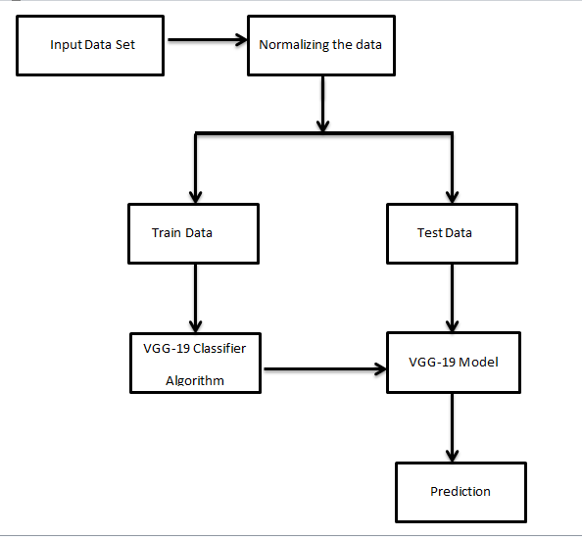

Figure 3.1: Project Architecture of Indoor scene classification using VGG-19

**3.2 DESCRIPTION**

Input Data: Input data is generally in .jpg format or .png format where the data is fetched from the directory mapped to the folder.

Reading Data: Open CV library is used to read the data.

Training and test data: Training data is passed to the VGG19 classifier to train the model. Test data is used to test the trained model whether it is making correct predictions or not.

VGG19 Classifier: the purpose of choosing the VGG19 classifier for this project is the efficiency and accuracy that we have observed when compared to other ML models.

**3.3 USE CASE DIAGRAM**

In the use case diagram we have basically two actors who are the user and the VGG-19. The user needs to upload the required image to the model. The Image is resized and classified by the VGG-19 model. The result of the classification and accuracy of the prediction can be accessed by the user. This process is graphically explained in the Figure 3.2: Use Case Diagram for user for Image Classifier to Identify Indoor Scenes.

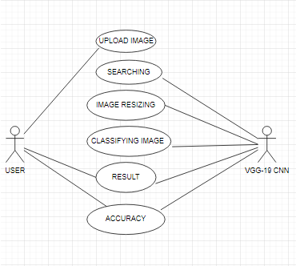

Figure 3.2: Use Case Diagram for user for Image Classifier to Identify Indoor Scenes

**3.4 CLASS DIAGRAM**

Class Diagram is a collection of classes and objects. As shown in the below Figure 3.3: Class Diagram for VGG-19 CNN and User for Image Classifier to Indoor Scene, We have 2 classes namely user and VGG-19. The objects of the user class are user name, upload, result, and accuracy. The objects of the VGG-19 class are image resizing, classification.

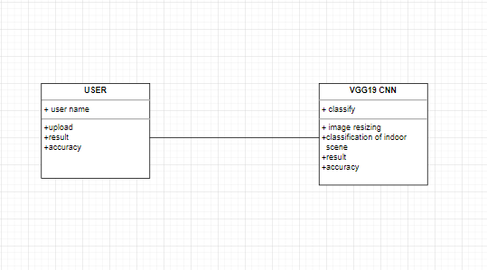

Figure 3.3: Class Diagram for VGG-19 CNN and User for Image Classifier to Indoor Scene

**3.5 SEQUENCE DIAGRAM**

The Figure 3.4: Sequence Diagram for Image Classifier to Identify Indoor Scene, is a graphical representation of the sequence of the operations performed by the VGG-19 classifier to predict the image.

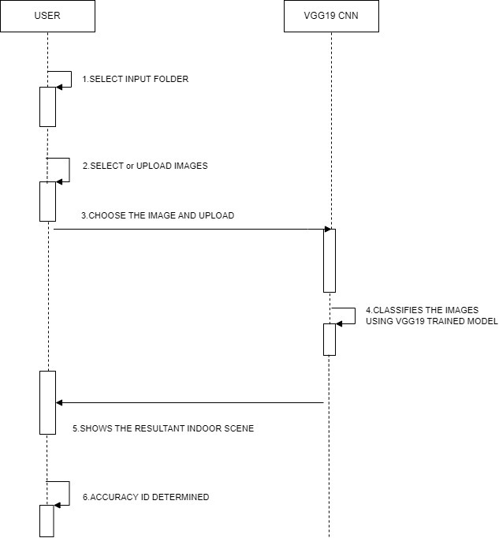

Figure 3.4: Sequence Diagram for Image Classifier to Identify Indoor Scene

3.6 ACTIVITY DIAGRAM

An activity diagram provides a view of the behaviour of a system by describing the sequence of actions in a process. The following Figure 3.5: Activity Diagram for User for VGG-19 Classifier to Identify Indoor scene explains the activity of the program graphically.

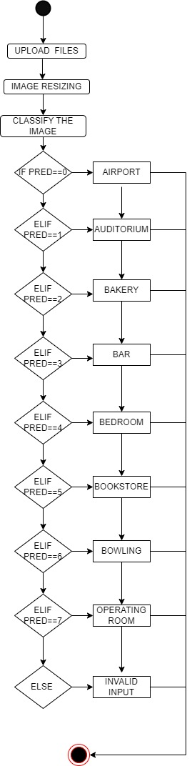

Figure 3.5: Activity Diagram for User for VGG-19 Classifier to Identify Indoor scene

**4. IMPLEMENTATION**

**4. IMPLEMENTATION**

**4.1 SAMPLE CODE**

#Imports drive modules from google.colab import drive.

#This is used to connect the google drive to the file for extraction of the data.

#Use cd command to change the directory of the file

#Imports library tensorflow for creating models

#Imports Keras from tensorflow.keras import layers as l

#Imports models from tensorflow.keras.models import model

#Imports adam from tensorflow.keras.optimizers imort adam

#Imports activation from tensorflow.keras.layers import Activation

#Imports Dense from tensorflow.keras.layers import Dense

# Imports flatten from tensorflow.keras.layers import Flatten

# Imports normalization from tensorflow.keras.layers import BatchNormalization

# Imports conv2 dimention from tensorflow.keras.layers import conv2D

# Imports max pooling layers from tensorflow.keras.layers import Maxpool2D

# Imports droupouts from tensorflow.keras.layers import Droupout

#Imports inputs from tensorflow.keras.layers import Input

#Imports numpy for mathematical calculations import numpy as np

#Imports VGG19 library from tensorflow.keras.application import VGG19

#imports backend from tensorflow.keras import backend as k

#imports open-cv libraries as import cv2

#imports matplotlib.pyplot as pt for graphical representation of the results

#imports os library for performing connection between the folders

#imports random to perform random selecting operations

#root_dir stores the data set directory

#folders contains the names of the classes used for the classification

#os.path.join(), joins the path and the folders

#Function listdir() is used for storing the files and folders of the root folder as a list.

#Function cv2.imread() reads the image files and stores them

#Variable img stores the image that is to be classified

#We perform the above 5 operations for all the folders and images in the root folder

#Image_Data_Generator() function is used to generate the image data

#Function create_vgg() creates the vgg19 classifier and generates the model for predicting images

#model.summary() function shows the layers created in the VGG19 classifier

#Function model.compile() is used to compile the model with the use of optimizer(Adam)

#Function Early_Stopping() is used to stop the epochs when the accuracy of the model is not increasing with the increasing of the epochs

#model.fit() function fits the training data in to the model and used no. of epochs to run the model that many times

#Function model.save() saves the model in the specified directory for further use and classification.

#Inference

#Function load.model() helps to load the saved model and run it with the test data set to get the prediction.

#pred_class() predicts the classes and gives out the name of the indoor scene.

**5. TESTING**

**5. TESTING**

**5.1 INTRODUCTION TO TESTING**

The purpose of testing is to discover errors. Testing is the process of trying to discover every conceivable fault or weakness in a work product. It provides a way to check the functionality of components, subassemblies, assemblies and/or a finished product. It is the process of exercising software with the intent of ensuring that the Software system meets its requirements and user expectations and does not fail in an unacceptable manner. There are various types of test. Each test type addresses a specific testing requirement.

**5.2 TYPES OF TESTING**

**5.2.1 UNIT TESTING**

Unit testing involves the design of test cases that validate that the internal program logic is functioning properly, and that program inputs produce valid outputs. All decision branches and internal code flow should be validated. It is the testing of individual software units of the application .it is done after the completion of an individual unit before integration. This is a structural testing, that relies on knowledge of its construction and is invasive. Unit tests perform basic tests at component level and test a specific business process, application, and/or system configuration. Unit tests ensure that each unique path of a business process performs accurately to the documented specifications and contains clearly defined inputs and expected results.

**5.2.2 INTEGRATION TESTING**

Integration tests are designed to test integrated software components to determine if they actually run as one program. Testing is event driven and is more concerned with the basic outcome of screens or fields. Integration tests demonstrate that although the components were individually satisfaction, as shown by successfully unit testing, the combination of components is correct and consistent. Integration testing is specifically aimed at exposing the problems that arise from the combination of components.

**5.2.3 FUNCTIONAL TESTING**

Functional tests provide systematic demonstrations that functions tested are available as specified by the business and technical requirements, system documentation, and user manuals. Functional testing is centred on the following items:

Valid Input : identified classes of valid input must be accepted.

Invalid Input : identified classes of invalid input must be rejected.

Functions : identified functions must be exercised.

Output : identified classes of application outputs must be exercised.

Systems/Procedures: interfacing systems or procedures must be invoked.

Organization and preparation of functional tests is focused on requirements, key functions, or special test cases. In addition, systematic coverage pertaining to identify Business process flows; data fields, predefined processes.

**5.3 TEST CASES**

**5.3.1 UPLOADING IMAGES**

|  |  |  |  |  |
| --- | --- | --- | --- | --- |
| Test case ID | Test case name | Purpose | Test Case | Output |
| 1 | User uploads image | Use it for identification | The user uploads airport indoor scene image | Uploaded successfully |
| 2 | User uploads 2nd image | Use it for identification | The user uploads bowling indoor scene image | Uploaded successfully |

**5.3.2 CLASSIFICATION**

|  |  |  |  |  |
| --- | --- | --- | --- | --- |
| Test case ID | Test case name | Purpose | Input | Output |
| 1 | Classification test 1 | To check if the classifier performs its task | An airport indoor scene image is given | It predicted as airport premises. |
| 2 | Classification test 2 | To check if the classifier performs its task | A bowling indoor scene image is given | It predicted as bowling premises. |
| 3 | Classification test 3 | To check if the classifier performs its task | A book store indoor scene image i s given | Predicted as book store premises |

**6. SCREENSHOTS**

**6. SCREENSHOTS**

**6.1 VGG19 RESULTS**

In the below screenshots we can see the results of VGG19 and CNN classifier. The following screenshot 6.1 shows us the classification of the airport premises, where it gives the details of the image in the text form.

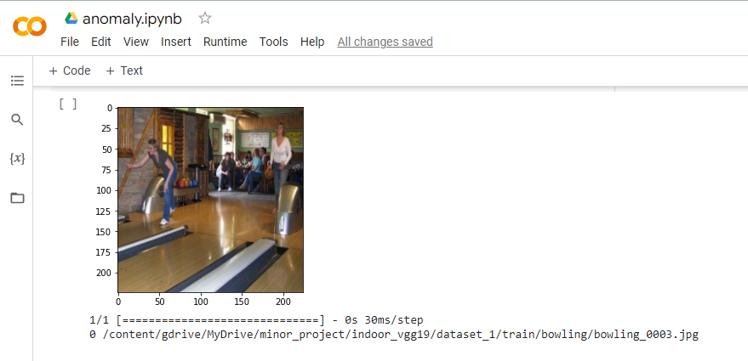



Screenshot 6.1: VGG19 Result

The following screenshot 6.2 shows us the classification of the bookstore premises, where it gives the details of the image in the text form.

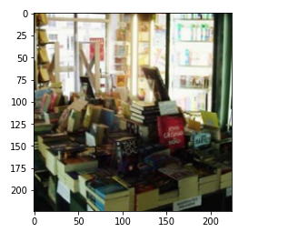



Screenshot 6.2: VGG19 Bookstore Result

The following screenshot 6.3 shows us the classification of the bowling premises, where it gives the details of the image in the form of text.

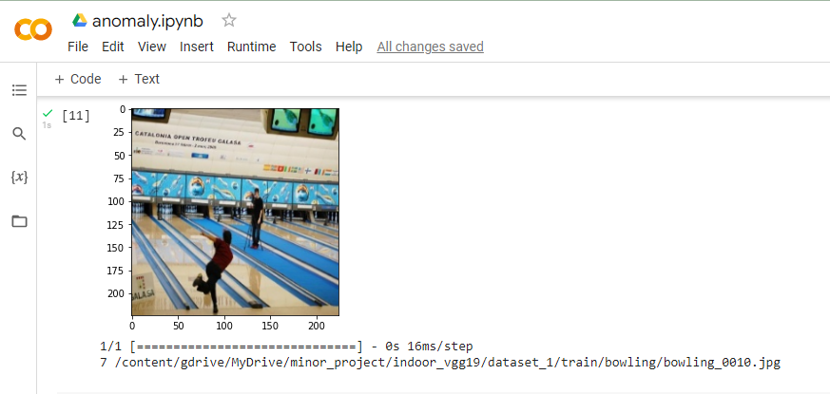



Screenshot 6.3: VGG19 Bowling Result

The following screenshot 6.4 shows us the classification of the toy store premises, where it gives the details of the image in the text form.

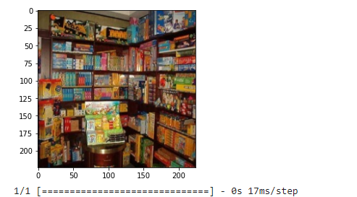



Screenshot 6.4:VGG19 Toy-store Result

**7. CONCLUSION**

**7. CONCLUSION & FUTURE SCOPE**

**7.1 PROJECT CONCLUSION**

The project titled as “Indoor Scene Classification using VGG-19 and CNN Classifier” is a console based application. This software provides facility for uploading the images and identifies the indoor scene and classify into various categories. This software is developed with scalability in mind. The software is developed with modular approach. All modules in the system have been tested with valid data and invalid data and everything work successfully. Thus the system has fulfilled all the objectives identified and is able to replace the existing system.

The constraints are met and overcome successfully. The system is designed as like it was decided in the design phase. The project gives good idea on developing a full-fledged application satisfying the user requirements.

The system is very flexible and versatile. Validation checks induced have greatly reduced errors. Provisions have been made to upgrade the software. The application has been tested with live data and has provided a successful result. Hence the software has proved to work efficiently.

**7.2 FUTURE SCOPE**

In future, we aim to add an interface to this project and build it in to a mobile/web application.

**8. BIBLIOGRAPHY**

**8. BIBLIOGRAPHY**

**8.1 REFERENCES**

1. Zhehang Tong*. Et al. A Review of Indoor-Outdoor Scene Classification: CAAI 2017.

**8.2 GITHUB LINK**

Git_hub link: https://github.com/discover2722/miniproject